Madagascar

## Freedom House political status

The data set shows the Freedom House political scores and status of the country each year.

## # A tibble: 19 x 5  
## country iso3c date mean status   
## <chr> <chr> <dbl> <dbl> <chr>   
## 1 Madagascar MDG 1996 3 Partly Free  
## 2 Madagascar MDG 1998 3 Partly Free  
## 3 Madagascar MDG 2000 3 Partly Free  
## 4 Madagascar MDG 2002 3.5 Partly Free  
## 5 Madagascar MDG 2003 3 Partly Free  
## 6 Madagascar MDG 2004 3 Partly Free  
## 7 Madagascar MDG 2005 3 Partly Free  
## 8 Madagascar MDG 2006 3.5 Partly Free  
## 9 Madagascar MDG 2007 3.5 Partly Free  
## 10 Madagascar MDG 2008 3.5 Partly Free  
## 11 Madagascar MDG 2009 5 Partly Free  
## 12 Madagascar MDG 2010 5 Partly Free  
## 13 Madagascar MDG 2011 5 Partly Free  
## 14 Madagascar MDG 2012 5 Partly Free  
## 15 Madagascar MDG 2013 4.5 Partly Free  
## 16 Madagascar MDG 2014 4 Partly Free  
## 17 Madagascar MDG 2015 3.5 Partly Free  
## 18 Madagascar MDG 2016 3.5 Partly Free  
## 19 Madagascar MDG 2017 3.5 Partly Free

## Freedom House classification of political change

The data set shows the GDP growth and the ecomic growth classification of the country each year.

## # A tibble: 19 x 4  
## country iso3c date politicalChangeFH  
## <chr> <chr> <dbl> <chr>   
## 1 Madagascar MDG 1996 no change   
## 2 Madagascar MDG 1998 no change   
## 3 Madagascar MDG 2000 no change   
## 4 Madagascar MDG 2002 autocratization   
## 5 Madagascar MDG 2003 democratization   
## 6 Madagascar MDG 2004 no change   
## 7 Madagascar MDG 2005 no change   
## 8 Madagascar MDG 2006 autocratization   
## 9 Madagascar MDG 2007 no change   
## 10 Madagascar MDG 2008 no change   
## 11 Madagascar MDG 2009 autocratization   
## 12 Madagascar MDG 2010 no change   
## 13 Madagascar MDG 2011 no change   
## 14 Madagascar MDG 2012 no change   
## 15 Madagascar MDG 2013 democratization   
## 16 Madagascar MDG 2014 democratization   
## 17 Madagascar MDG 2015 democratization   
## 18 Madagascar MDG 2016 no change   
## 19 Madagascar MDG 2017 no change

## Freedom House score trend

The plot shows the Freedom House scores trend of the country.

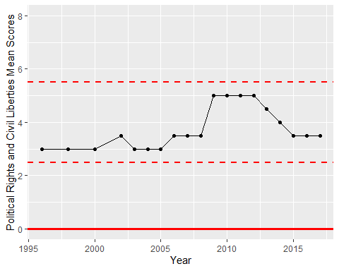

Freedom House Score Trend